**MLP-DRIVEN MALARIA DISEASE OUTBREAK ANALYSIS FROM ENVIRONMENTAL DATA FOR PUBLIC HEALTH MANAGEMENT**

**Abstract**

Malaria diagnosis relied heavily on manual microscopy, where a skilled technician examines blood smears under a microscope to identify and count malaria parasites. This method, established in the early 1900s, has been the gold standard for malaria diagnosis but is labor-intensive, time-consuming, and requires significant expertise. In regions with limited healthcare resources, this has often led to misdiagnosis or delayed treatment. The objective of this study is to leverage DL learning techniques to develop an automated, accurate, and efficient diagnostic tool for detecting malaria infections from medical images, thereby improving diagnostic accuracy and reducing the time required for analysis., to analyze medical images and diagnose malaria infections. The approach aims to automate the detection process, making it faster and more reliable compared to traditional methods. Before the advent of machine learning or AI, the primary method for diagnosing malaria was manual microscopy, as mentioned earlier. This involved staining blood smears with special dyes, followed by meticulous examination under a microscope. The accuracy of this method largely depended on the technician’s experience and the quality of the equipment, which could vary significantly, especially in low-resource settings. Traditional microscopy for malaria diagnosis, while effective, has several limitations, including the need for skilled personnel, the potential for human error, and the slow turnaround time for results. The motivation for this research stems from the need to address the shortcomings of traditional malaria diagnostic methods. With the global burden of malaria remaining high, especially in low-income countries, there is a pressing need for diagnostic tools that are not only accurate but also accessible and scalable. The proposed system involves the development of a DL learning model trained on a large dataset of labeled blood smear images. This model will automatically detect and classify malaria parasites in the images, offering a quick and accurate diagnosis. By reducing reliance on human expertise, this system can provide consistent results across different settings, enhance early detection, and enable prompt treatment, ultimately contributing to better malaria control and eradication efforts.

**CHAPTER 1**

**INTRODUCTION**

The integration of DL learning into medical diagnostics offers a revolutionary approach to disease detection. By automating the analysis of medical images, DL learning can significantly improve the speed and accuracy of malaria diagnosis. This technology is particularly vital in regions with limited access to skilled healthcare professionals, where rapid and reliable diagnostics can save lives.

**1.1 Background and History**

Malaria remains one of the most significant public health challenges globally, particularly in regions like sub-Saharan Africa and South Asia. In India, malaria has been a persistent threat, with millions of cases reported annually, primarily in states like Odisha, Chhattisgarh, and Jharkhand. According to the World Health Organization (WHO), India accounted for nearly 4% of the world's malaria cases in 2020. The traditional method of diagnosing malaria involves microscopic examination of stained blood smears to identify and count the presence of *Plasmodium* parasites. This method, while effective, is highly dependent on the expertise of trained technicians and the quality of the equipment used, often leading to inconsistencies in diagnosis. The manual process is labor-intensive and time-consuming, making it less feasible in resource-limited settings where malaria is most prevalent.

**1.2 Problem Definition**

Before the advent of machine learning, the primary challenge in malaria diagnosis was the heavy reliance on manual microscopy. This method required skilled technicians to examine blood smears under a microscope, a process that was both time-consuming and prone to human error. In regions with limited healthcare resources, this often led to misdiagnosis or delayed treatment, exacerbating the burden of the disease and hindering effective malaria control efforts.

**1.3 Research Motivation**

The motivation for this research is driven by the urgent need to overcome the limitations of traditional malaria diagnostics. With the global burden of malaria remaining high, particularly in low-income countries, there is a critical need for diagnostic tools that are not only accurate but also accessible and scalable. The goal is to harness the power of DL learning to create a diagnostic tool that can operate efficiently in various settings, providing rapid and reliable results that can enhance early detection and treatment of malaria.

**1.4 Existing System and Drawbacks**

The existing system for malaria diagnosis relies heavily on manual microscopy, which, despite being the gold standard, has significant drawbacks. It requires specialized training, is labor-intensive, and is prone to human error, particularly in high-volume settings. Additionally, the quality of diagnosis can vary depending on the technician’s experience and the equipment used, leading to inconsistent results and potential delays in treatment.

**1.5 Proposed System**

The proposed system involves implementing a DL learning model specifically designed to detect malaria parasites in blood smear images. This model will be trained on a large dataset of labeled images, allowing it to learn and identify the distinctive features of malaria parasites. Techniques such as Convolutional Neural Networks (CNNs), which are highly effective in image classification tasks, will be employed. Research papers on similar approaches, such as "Malaria Detection and Classification Using Convolutional Neural Networks" (2020) and "Automated Detection of Malaria Parasites in Thick Blood Smears Using DL Learning" (2019), provide a solid foundation for the development of this system. The automated detection process not only reduces the need for specialized training but also ensures consistent and rapid diagnosis, which is critical for timely treatment and control of malaria.

**1.6 Real-Time Need**

In real-world scenarios, especially in remote or underdeveloped regions, access to trained medical personnel and advanced diagnostic equipment is often limited. This leads to delays in diagnosis and treatment, contributing to higher morbidity and mortality rates. An automated, DL learning-based diagnostic tool can bridge this gap by providing a reliable, fast, and accessible means of diagnosing malaria. It can be deployed in clinics, hospitals, and even mobile health units, ensuring that patients receive accurate diagnoses and timely treatment, regardless of their location.

**1.7 Application**

The applications of this project extend beyond just malaria diagnosis. The developed DL learning model can be adapted to diagnose other parasitic infections by training it on relevant medical images. In addition, this technology can be integrated into telemedicine platforms, allowing remote diagnostics in areas with limited healthcare infrastructure. Healthcare providers can use this tool to screen large populations quickly, improving public health outcomes through early detection and treatment. Furthermore, the system can be used in research settings to analyze large datasets of blood smears, contributing to epidemiological studies and the development of new treatment strategies. Ultimately, this project has the potential to revolutionize infectious disease diagnostics, making it a vital tool in the global fight against malaria and other parasitic diseases.

**CHAPTER 2**

**LITERATURE SURVEY**

David H. et al. [1] provided a comprehensive overview of the principles of data mining, focusing on its application across various domains, including healthcare. Koh H.C. et al. [2] emphasized the potential of data mining techniques in enhancing healthcare decision support systems, demonstrating how these methods can improve patient care and optimize resource management. Building on these concepts, Tomar D. et al. [3] conducted a survey on data mining approaches specifically within the healthcare sector, detailing various methodologies and their effectiveness in clinical settings. The World Health Organization [4] highlighted the global burden of malaria, particularly in Africa, and the need for advanced diagnostic tools. Roca-Feltrer A. et al. [5] estimated the malaria morbidity in African children under five years, stressing the importance of effective disease management and prevention strategies, which could be informed by data mining and analysis. Ibrahim et al. [6] in their study compared different classification techniques using WEKA for breast cancer. The aim of the study is to investigate the performance of different classification methods for a set of large datasets. The algorithms tested are Bayes Network, Radial Basis Function, Pruned Tree, Single Conjunctive Rule learner and Nearest Neighbours. The best algorithm on the breast cancer data sets is Bayes network classifier with the highest accuracy and lowest average error. Boris and Milan [7] performed prediction and decision making in healthcare using data mining. They analysed the usefulness of data mining in the healthcare sector and some of the obstacles that disable the effective and efficient prediction. Sharma et al. [8] in their study presented malaria outbreak prediction model using machine learning. In this study, they stated that the early prediction of malaria outbreak is the key to the control of malaria morbidity. This prediction can help as an early warning tool to identify potential outbreaks of malaria. The machine learning used for the data mining was classification algorithms based on support vector machine (SVM) and artificial neural network (ANN). Also, the total number of Plasmodium falciparum cases and an outbreak occurs in binary values yes or no. Root mean square error (RMSE) and receivers operating characteristics (ROC) were used to measure the performance of the models. Kapor and Rani [9] employed an efficient decision tree algorithm using J48 and reduced error pruning. In the study, decision trees were utilized to delineate decision-making process. The decision tree builds classification or regression models in the form of the tree structure, which divides the datasets into tinier and tinier subsets. Some of the benefits and limitations of the decision trees where highlighted. The paper introduces a new decision tree algorithm based on J48 and reduced error pruning. The tree obtained is fast decision tree learning and will be based on the information gain or reducing the variance. Leopard et al. [10] worked on survey and analysis on classification and regression data mining techniques for disease outbreak prediction in datasets. In this study, the need to develop a strong model for the prediction of disease outbreak in various countries using data mining algorithms was discussed. The advantages and disadvantages of the different classification techniques were highlighted and also the accuracy measures in decision trees from previous publications from the year 2001 to 2014 were presented. Bbosa et al. [11] studied clinical malaria diagnosis: ruled-based classification statistical prototype. In the study, they were able to identify the predictors of malaria, developed data mining, statistically enhanced rule-based classification to diagnose malaria and developed an automated system to incorporate the rules and the statistical models. The prototype was evaluated for efficacy showing a sensitivity value of 70% across the age groups. They also presented tables for malaria prevalence, signs and symptoms of both hospital and diagnosis. Witten I.H. et al. [12, 15] discussed the practical aspects of data mining and machine learning, introducing tools and techniques essential for extracting meaningful patterns from large datasets, with a particular focus on the WEKA workbench [20]. Cao X. et al. [13] applied data mining techniques to analyze cancer vaccine trials, offering a high-level overview of the data's impact on immunology research. Cios K.J. et al. [14] highlighted the unique challenges of medical data mining, emphasizing its complexity and the need for specialized methods. Han J. et al. [16] explored advanced concepts and techniques in data mining, providing a comprehensive guide to handling large datasets, while Quinlan R. [17] introduced the C4.5 algorithm, a seminal contribution to machine learning for building decision trees. Sumner M. et al. [18] focused on optimizing logistic model tree induction, presenting techniques to enhance computational efficiency. Hulten G. et al. [19] tackled the challenges of mining time-changing data streams, contributing to the development of methods that adapt to dynamic data environments.

**CHAPTER 3**

**EXISTING SYSTEM**

**3.1 Traditional System**

Before the advent of Artificial Intelligence (AI) and DL learning, the primary method for diagnosing malaria was manual microscopy, a practice that has been in use for over a century. This technique involves collecting a blood sample from the patient, which is then smeared onto a glass slide and stained with specific dyes, such as Giemsa stain, to highlight the malaria parasites. A trained technician or pathologist examines the stained blood smear under a microscope, carefully searching for and identifying the parasites based on their appearance and distinguishing features. The process also includes counting the number of parasites present to estimate the severity of the infection.

Manual microscopy has been regarded as the gold standard for malaria diagnosis due to its ability to directly detect and visualize the parasites within red blood cells. However, it is a labor-intensive and time-consuming process that requires a high level of expertise. The accuracy of the diagnosis depends significantly on the skill and experience of the technician, as well as the quality of the microscope and staining reagents used.

In regions with limited healthcare resources, the traditional method poses several challenges. The shortage of skilled personnel often leads to misdiagnosis or delayed diagnosis, which can result in improper treatment and increased mortality rates. Furthermore, the variability in diagnostic accuracy due to human error and differences in equipment quality can compromise the effectiveness of malaria control programs, especially in areas with a high prevalence of the disease. These limitations underscore the need for more reliable, efficient, and accessible diagnostic tools.

**3.2 Limitations of the Traditional System**

The traditional microscopy-based method for diagnosing malaria, while widely used, has several limitations that hinder its effectiveness in both low-resource and well-equipped settings. Below are the key limitations:

1. **Dependency on Skilled Personnel**:
   * **Expertise Required**: Accurate malaria diagnosis through microscopy requires highly trained technicians or pathologists. The effectiveness of the diagnosis heavily depends on the experience and skill of the technician, which can vary greatly, particularly in low-resource regions.
   * **Human Resources**: In many endemic regions, there is a significant shortage of skilled personnel capable of performing accurate malaria diagnoses. This scarcity can lead to overburdened healthcare workers, further increasing the chances of error.
2. **Time-Consuming Process**:
   * **Labor-Intensive**: The manual examination of blood smears is a slow and labor-intensive process. Each slide requires careful inspection, often taking 20-30 minutes per patient, which limits the number of diagnoses that can be performed in a given timeframe.
   * **Delayed Results**: The time required to process and examine multiple samples can lead to delays in diagnosis and treatment, which is critical in managing malaria, particularly in severe cases where prompt intervention is necessary.
3. **Susceptibility to Human Error**:
   * **Subjectivity in Diagnosis**: The identification and counting of malaria parasites are subjective processes that can vary from one technician to another. This subjectivity introduces a risk of misdiagnosis, either through false positives or false negatives.
   * **Fatigue and Inconsistency**: Given the meticulous nature of the task, technicians may experience fatigue, leading to decreased accuracy and consistency in diagnosing malaria, especially in high-volume testing environments.
4. **Quality of Equipment**:
   * **Microscope Quality**: The effectiveness of the traditional method is also influenced by the quality of the microscope and staining reagents. In low-resource settings, where equipment may be outdated or poorly maintained, the diagnostic accuracy can be significantly compromised.
   * **Inconsistent Staining**: Variability in the staining process can affect the visibility of parasites, making accurate detection more difficult and further contributing to diagnostic inconsistencies.
5. **Limited Accessibility**:
   * **Infrastructure Constraints**: In remote or rural areas, access to well-equipped laboratories and skilled technicians is often limited. This constraint reduces the reach of effective malaria diagnosis and treatment, contributing to higher morbidity and mortality rates in such regions.
6. **High Costs**:
   * **Resource-Intensive**: The need for high-quality equipment, stains, and skilled personnel makes traditional microscopy an expensive method, particularly in regions with limited healthcare budgets.

**CHAPTER 4**

**PROPOSED SYSTEM**

**4.1 Overview**

DL learning-based approach for analyzing malaria infection data. It starts by preprocessing the dataset, including resampling and encoding categorical variables using LabelEncoder. The data is split into training and testing sets, and various machine learning models like Decision Tree and MLP (Multi-Layer Perceptron) are trained to predict malaria outbreak thresholds. Metrics like Mean Squared Error (MSE) and R² score are calculated to evaluate model performance. Finally, the trained models are used to make predictions on a test dataset, with results saved and displayed.

Figure 4.1: Block Diagram

**Step 1: Dataset**

* The dataset "malaria.csv" is utilized, which contains information related to malaria infection, including features such as mosquito species and outbreak thresholds. This dataset is the foundation for training and testing the machine learning models.

**Step 2: Dataset Preprocessing**

* **Null Value Removal:** The dataset is checked for any missing or null values, which are removed to ensure data quality.
* **Label Encoding:** The categorical features within the dataset are converted into numerical values using label encoding. This is essential for machine learning models to process the data effectively.

**Step 3: Label Encoder**

* A label encoder is applied to all categorical columns within the dataset to transform them into numerical values. This step ensures that the data can be fed into machine learning models without any issues.

**Step 4: Data Splitting**

* The dataset is split into training and testing sets using an 80-20 split. This is crucial for evaluating the model's performance on unseen data.

**Step 5: Existing Model (Decision Tree Regressor)**

* A Decision Tree Regressor model is trained on the processed data. This model serves as a baseline to compare against the proposed model.
* The model is evaluated using metrics such as Mean Squared Error (MSE) and R^2 Score.

**Step 6: Proposed Model (MLP Regressor)**

* The proposed model is a Multi-Layer Perceptron (MLP) Regressor, which is a type of DL learning model.
* This model is trained on the same dataset and compared against the Decision Tree Regressor.
* The MLP Regressor is expected to provide better accuracy and performance due to its complex architecture.

**Step 7: Performance Comparison**

* The performance of the Decision Tree Regressor and MLP Regressor is compared using metrics such as Mean Squared Error (MSE) and R^2 Score.
* The comparison helps in determining the effectiveness of the proposed DL learning model over the traditional machine learning model.

**Step 8: Prediction of Output from Test Data (Using MLP Model)**

* The trained MLP model is used to predict outcomes on new test data.
* The predictions are compared with the actual values to evaluate the model's accuracy and reliability.
* The results are then added to the test dataset, which now includes the predicted values.

**4.2 Data Splitting & Preprocessing**

**Data Splitting:**

* The dataset is divided into two subsets: a **training set** and a **testing set**. Typically, this split is done using an 80-20 ratio, where 80% of the data is used to train the machine learning models, and the remaining 20% is reserved for testing and evaluating the model's performance on unseen data. This ensures that the model's accuracy is not just due to memorization of the training data but can generalize well to new data.

**Preprocessing:**

1. **Handling Missing Values:**
   * The dataset is first checked for any missing or null values. If any are found, they are either filled with appropriate values (such as the mean, median, or mode) or removed entirely to maintain data integrity.
2. **Label Encoding:**
   * Since machine learning models require numerical input, all categorical features in the dataset are converted into numerical values using a technique called label encoding. Label encoding assigns a unique integer to each category, enabling the model to process categorical data effectively.
3. **Feature Scaling:**
   * In some cases, feature scaling is applied to standardize the range of independent variables or features. This is especially important when features vary significantly in their ranges. Standard scaling (subtracting the mean and dividing by the standard deviation) is commonly used to ensure that each feature contributes equally to the model's learning process.
4. **Resampling:**
   * If the dataset is imbalanced (e.g., one class significantly outnumbers the others), resampling techniques like oversampling the minority class or undersampling the majority class may be applied to balance the dataset. This helps in improving the model's performance, particularly for minority classes.

**4.3 DL Model Building**

Once the model is selected, it is trained using the training dataset. During training, the model learns the relationships between the input features and the output labels by adjusting its internal parameters. This process involves feeding the data into the model, computing the error (difference between predicted and actual outcomes), and optimizing the model parameters to minimize this error. Training is typically done iteratively, with the model improving its predictions over time. Techniques like cross-validation can be used during training to tune hyperparameters and prevent overfitting, ensuring the model generalizes well to new data.

**4.3.1 Existing Algorithm: Decision Tree Regressor**

A Decision Tree Regressor is a type of supervised learning algorithm used for regression tasks, where the goal is to predict a continuous value based on input features. Unlike classification tasks that predict categorical labels, regression predicts numeric outcomes, such as predicting a person's income, house prices, or in this context, malaria outbreak thresholds.

**How It Works:** A Decision Tree Regressor works by splitting the data into subsets based on the most significant features at each step. The algorithm begins at the root of the tree, where all the data points are grouped together. It then selects the best feature to split the data into smaller subsets, aiming to minimize the prediction error (often using a metric like Mean Squared Error). This process is repeated recursively for each subset, creating branches and nodes that eventually lead to leaf nodes, where the final prediction is made.

At each split, the algorithm looks for the feature and corresponding threshold that result in the largest reduction in variance (for regression tasks). The data is divided based on this feature, and the process continues until a stopping criterion is met, such as a maximum tree depth or a minimum number of samples per leaf node.

**Architecture:**

* **Root Node:** The topmost node in the tree, representing the entire dataset.
* **Internal Nodes:** Nodes where the data is split based on specific features.
* **Leaf Nodes:** The terminal nodes where the final prediction is made. Each leaf node contains a predicted value.
* **Branches:** Pathways that connect nodes and represent the decision rules leading from one node to another.

The architecture of a Decision Tree is hierarchical, with decisions made at each level based on the input features. The tree can grow DL, with many layers, depending on the complexity of the dataset and the stopping criteria set by the user.

**Disadvantages:**

* **Overfitting:** Decision Trees can easily become overly complex, leading to overfitting where the model performs well on the training data but poorly on unseen data.
* **High Variance:** Small changes in the data can lead to significant changes in the tree structure, making the model sensitive to noise.
* **Bias towards Dominant Features:** Decision Trees tend to favor features with more levels or higher cardinality, which might not always be the most important features.
* **Interpretability in Large Trees:** While small trees are easy to interpret, large trees can become cumbersome and difficult to understand.

**4.3.2 Proposed Algorithm: Multi-Layer Perceptron (MLP)**

A Multi-Layer Perceptron (MLP) is a class of feedforward artificial neural network (ANN) that consists of multiple layers of nodes. It is widely used for both regression and classification tasks. Each node (or neuron) in the network represents a mathematical function that computes a weighted sum of the inputs and applies an activation function to produce the output.

**How It Works:** An MLP operates by passing input data through multiple layers of neurons. Each layer in the network consists of several neurons, and each neuron in a layer is connected to every neuron in the subsequent layer, making the network "fully connected."

1. **Input Layer:** Receives the input data. The number of neurons in this layer corresponds to the number of features in the dataset.
2. **Hidden Layers:** One or more intermediate layers where the network performs most of its computations. Each neuron in these layers processes the inputs from the previous layer and passes the output to the next layer. The weights of these connections are adjusted during the training process to minimize the error in predictions.
3. **Output Layer:** Produces the final output of the network. In regression tasks, this is typically a single neuron that provides the predicted continuous value.

Training an MLP involves adjusting the weights of the connections between neurons using a process called backpropagation. Backpropagation calculates the error at the output and propagates it backward through the network to update the weights, typically using an optimization technique like gradient descent.

**Architecture:**

* **Input Layer:** Neurons correspond to the input features.
* **Hidden Layers:** Consist of neurons connected with activation functions like ReLU (Rectified Linear Unit), Sigmoid, or Tanh that introduce non-linearity.
* **Output Layer:** A single neuron in the case of regression, which outputs the predicted value.

The architecture of an MLP can vary in terms of the number of hidden layers and the number of neurons per layer. A DLer network (with more hidden layers) can capture more complex patterns but may require more computational resources and careful tuning to prevent overfitting.

**Advantages:**

* **Ability to Model Complex Relationships:** MLPs can capture and model complex, non-linear relationships in data, making them suitable for tasks where simple models like linear regression fall short.
* **Scalability:** MLPs can be scaled up by adding more layers or neurons, allowing them to tackle larger and more complex problems.
* **Flexibility:** MLPs can be used for a variety of tasks, including both regression and classification, by adjusting the architecture and activation functions.
* **Automated Feature Engineering:** Unlike some traditional models, MLPs can learn and optimize features during training, reducing the need for manual feature engineering.

**CHAPTER 5**

**UDL DIAGRAMS**

UDL stands for Unified Modeling Language. UDL is a standardized general-purpose modeling language in the field of object-oriented software engineering. The standard is managed, and was created by, the Object Management Group. The goal is for UDL to become a common language for creating models of object-oriented computer software. In its current form UDL is comprised of two major components: a Meta-model and a notation. In the future, some form of method or process may also be added to; or associated with, UDL.

The Unified Modeling Language is a standard language for specifying, Visualization, Constructing and documenting the artifacts of software system, as well as for business modeling and other non-software systems. The UDL represents a collection of best engineering practices that have proven successful in the modeling of large and complex systems. The UDL is a very important part of developing objects-oriented software and the software development process. The UDL uses mostly graphical notations to express the design of software projects.

**GOALS:** The Primary goals in the design of the UDL are as follows:

* Provide users a ready-to-use, expressive visual modeling Language so that they can develop and exchange meaningful models.
* Provide extendibility and specialization mechanisms to extend the core concepts.
* Be independent of particular programming languages and development process.
* Provide a formal basis for understanding the modeling language.
* Encourage the growth of OO tools market.
* Support higher level development concepts such as collaborations, frameworks, patterns and components.
* Integrate best practices.

**Class diagram**

The class diagram is used to refine the use case diagram and define a detailed design of the system. The class diagram classifies the actors defined in the use case diagram into a set of interrelated classes. The relationship or association between the classes can be either an "is-a" or "has-a" relationship. Each class in the class diagram was capable of providing certain functionalities. These functionalities provided by the class are termed "methods" of the class. Apart from this, each class may have certain "attributes" that uniquely identify the class.

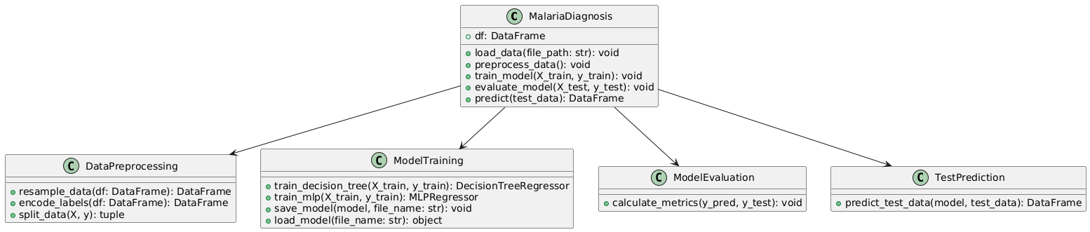

Figure-5.1: Class Diagram

**Sequence Diagram**

A sequence diagram in Unified Modeling Language (UDL) is a kind of interaction diagram that shows how processes operate with one another and in what order. It is a construct of a Message Sequence Chart. A sequence diagram shows, as parallel vertical lines (“lifelines”), different processes or objects that live simultaneously, and as horizontal arrows, the messages exchanged between them, in the order in which they occur. This allows the specification of simple runtime scenarios in a graphical manner.

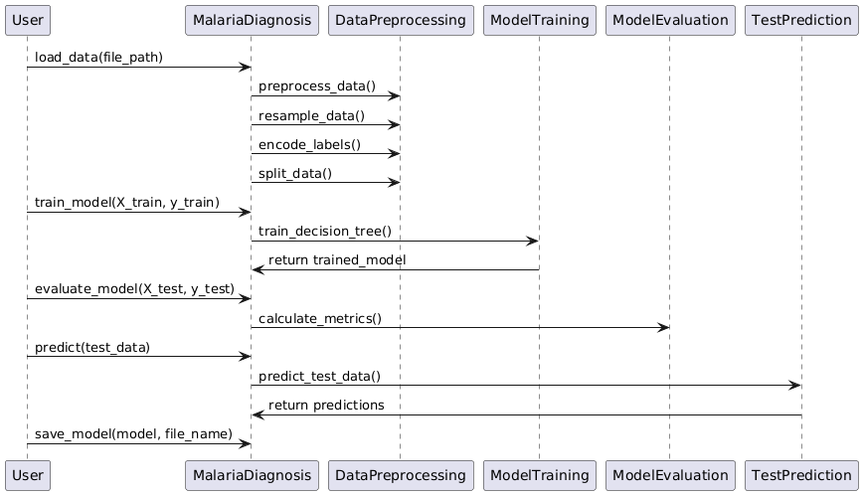

Figure-5.2: Sequence Diagram

**Activity diagram**

Activity diagrams are graphical representations of Workflows of stepwise activities and actions with support for choice, iteration, and concurrency. In the Unified Modeling Language, activity diagrams can be used to describe the business and operational step-by-step workflows of components in a system. An activity diagram shows the overall flow of control.

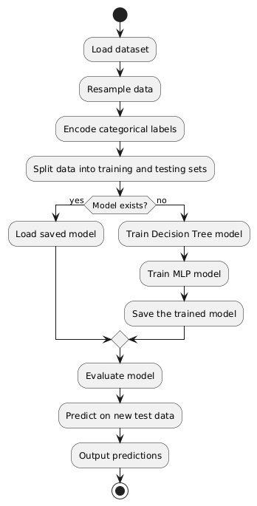

Figure-5.3: Activity Diagram

**Data flow diagram**

A data flow diagram (DFD) is a graphical representation of how data moves within an information system. It is a modeling technique used in system analysis and design to illustrate the flow of data between various processes, data stores, data sources, and data destinations within a system or between systems. Data flow diagrams are often used to depict the structure and behavior of a system, emphasizing the flow of data and the transformations it undergoes as it moves through the system.

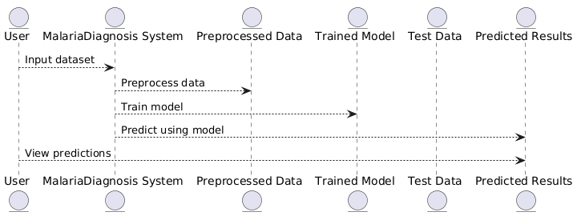

Figure-5.4: Dataflow Diagram

**Component diagram:** Component diagram describes the organization and wiring of the physical components in a system.

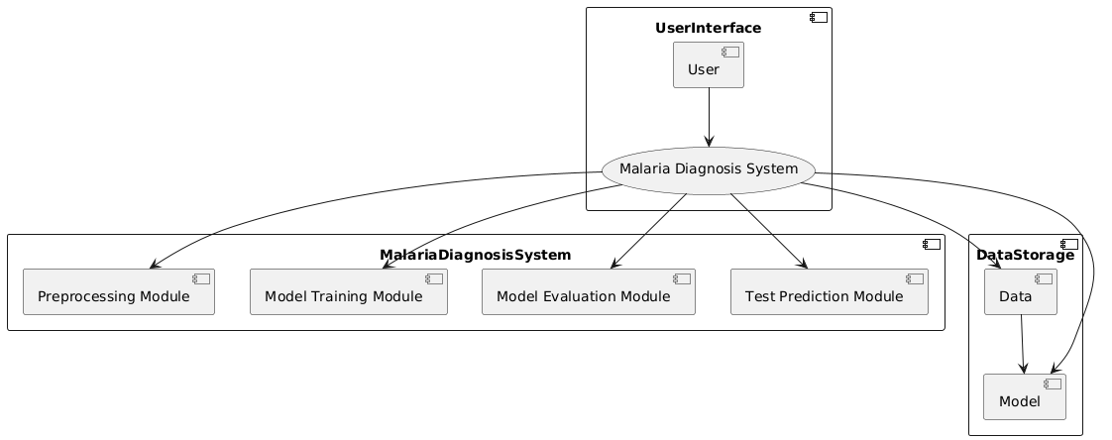

Figure-5.5: Component Diagram

**Use Case diagram:** A use case diagram in the Unified Modeling Language (UDL) is a type of behavioral diagram defined by and created from a Use-case analysis. Its purpose is to present a graphical overview of the functionality provided by a system in terms of actors, their goals (represented as use cases), and any dependencies between those use cases. The main purpose of a use case diagram is to show what system functions are performed for which actor. Roles of the actors in the system can be depicted.

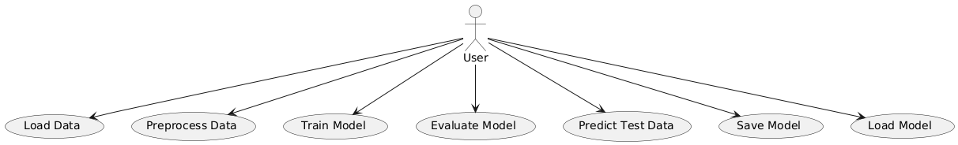

Figure-5.6: use case diagram

**Deployment Diagram:**

A deployment diagram in UDL illustrates the physical arrangement of hardware and software components in the system. It visualizes how different software artifacts, such as data processing scripts and model training components, are deployed across hardware nodes and interact with each other, providing insight into the system’s infrastructure and deployment strategy.

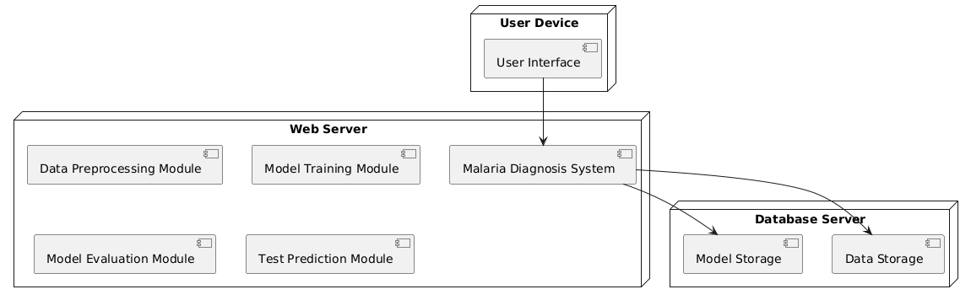

Figure-5.7: DeploymentDiagram

**Architectural Block Diagram**

An architectural block diagram offers a high-level view of a system’s structure, showcasing the main components and their interactions. It represents how major modules, such as data sources, processing units, and evaluation components, are organized and how they communicate with each other to accomplish the system’s objectives. This diagram helps in understanding the overall design and flow of the system.

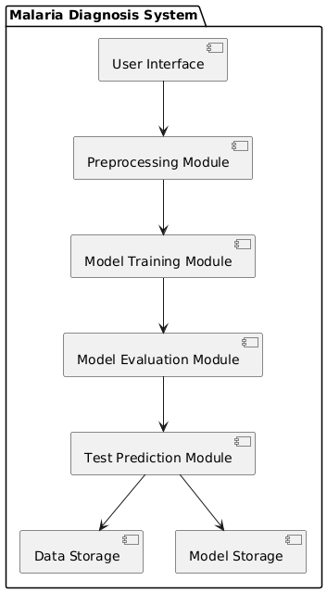

Figure-5.8: architectural block diagram

**CHAPTER 6**

**SOFTWARE ENVIRONMENT**

**What is Python?**

Below are some facts about Python.

* Python is currently the most widely used multi-purpose, high-level programming language.
* Python allows programming in Object-Oriented and Procedural paradigms. Python programs generally are smaller than other programming languages like Java.
* Programmers have to type relatively less and indentation requirement of the language, makes them readable all the time.
* Python language is being used by almost all tech-giant companies like – Google, Amazon, Facebook, Instagram, Dropbox, Uber… etc.

The biggest strength of Python is huge collection of standard library which can be used for the following –

* Machine Learning
* GUI Applications (like Kivy, Tkinter, PyQt etc. )
* Web frameworks like Django (used by YouTube, Instagram, Dropbox)
* Image processing (like Opencv, Pillow)
* Web scraping (like Scrapy, BeautifulSoup, Selenium)
* Test frameworks
* Multimedia

**Advantages of Python**

Let’s see how Python dominates over other languages.

1. **Extensive Libraries**

Python downloads with an extensive library and it contain code for various purposes like regular expressions, documentation-generation, unit-testing, web browsers, threading, databases, CGI, email, image manipulation, and more. So, we don’t have to write the complete code for that manually.

**2. Extensible**

As we have seen earlier, Python can be extended to other languages. You can write some of your code in languages like C++ or C. This comes in handy, especially in projects.

**3. Embeddable**

Complimentary to extensibility, Python is embeddable as well. You can put your Python code in your source code of a different language, like C++. This lets us add scripting capabilities to our code in the other language.

**4. Improved Productivity**

The language’s simplicity and extensive libraries render programmers more productive than languages like Java and C++ do. Also, the fact that you need to write less and get more things done.

**5. IOT Opportunities**

Since Python forms the basis of new platforms like Raspberry Pi, it finds the future bright for the Internet Of Things. This is a way to connect the language with the real world.

**6. Simple and Easy**

When working with Java, you may have to create a class to print ‘Hello World’. But in Python, just a print statement will do. It is also quite easy to learn, understand, and code. This is why when people pick up Python, they have a hard time adjusting to other more verbose languages like Java.

**7. Readable**

Because it is not such a verbose language, reading Python is much like reading English. This is the reason why it is so easy to learn, understand, and code. It also does not need curly braces to define blocks, and indentation is mandatory. This further aids the readability of the code.

**8. Object-Oriented**

This language supports both the procedural and object-oriented programming paradigms. While functions help us with code reusability, classes and objects let us model the real world. A class allows the encapsulation of data and functions into one.

**9. Free and Open-Source**

Like we said earlier, Python is freely available. But not only can you download Python for free, but you can also download its source code, make changes to it, and even distribute it. It downloads with an extensive collection of libraries to help you with your tasks.

**10. Portable**

When you code your project in a language like C++, you may need to make some changes to it if you want to run it on another platform. But it isn’t the same with Python. Here, you need to code only once, and you can run it anywhere. This is called Write Once Run Anywhere (WORA). However, you need to be careful enough not to include any system-dependent features.

**11. Interpreted**

Lastly, we will say that it is an interpreted language. Since statements are executed one by one, debugging is easier than in compiled languages.

Any doubts till now in the advantages of Python? Mention in the comment section.

**Advantages of Python Over Other Languages**

1. **Less Coding**

Almost all of the tasks done in Python requires less coding when the same task is done in other languages. Python also has an awesome standard library support, so you don’t have to search for any third-party libraries to get your job done. This is the reason that many people suggest learning Python to beginners.

**2. Affordable**

Python is free therefore individuals, small companies or big organizations can leverage the free available resources to build applications. Python is popular and widely used so it gives you better community support.

The 2019 Github annual survey showed us that Python has overtaken Java in the most popular programming language category.

**3. Python is for Everyone**

Python code can run on any machine whether it is Linux, Mac or Windows. Programmers need to learn different languages for different jobs but with Python, you can professionally build web apps, perform data analysis and machine learning, automate things, do web scraping and also build games and powerful visualizations. It is an all-rounder programming language.

**Disadvantages of Python**

So far, we’ve seen why Python is a great choice for your project. But if you choose it, you should be aware of its consequences as well. Let’s now see the downsides of choosing Python over another language.

1. **Speed Limitations**

We have seen that Python code is executed line by line. But since Python is interpreted, it often results in slow execution. This, however, isn’t a problem unless speed is a focal point for the project. In other words, unless high speed is a requirement, the benefits offered by Python are enough to distract us from its speed limitations.

**2. Weak in Mobile Computing and Browsers**

While it serves as an excellent server-side language, Python is much rarely seen on the client-side. Besides that, it is rarely ever used to implement smartphone-based applications. One such application is called Carbonnelle.

The reason it is not so famous despite the existence of Brython is that it isn’t that secure.

**3. Design Restrictions**

As you know, Python is dynamically typed. This means that you don’t need to declare the type of variable while writing the code. It uses duck-typing. But wait, what’s that? Well, it just means that if it looks like a duck, it must be a duck. While this is easy on the programmers during coding, it can raise run-time errors.

**4. Underdeveloped Database Access Layers**

Compared to more widely used technologies like JDBC (Java DataBase Connectivity) and ODBC (Open DataBase Connectivity), Python’s database access layers are a bit underdeveloped. Consequently, it is less often applied in huge enterprises.

**5. Simple**

No, we’re not kidding. Python’s simplicity can indeed be a problem. Take my example. I don’t do Java, I’m more of a Python person. To me, its syntax is so simple that the verbosity of Java code seems unnecessary.

This was all about the Advantages and Disadvantages of Python Programming Language.

**Modules Used in Project**

**NumPy**

NumPy is a general-purpose array-processing package. It provides a high-performance multidimensional array object, and tools for working with these arrays.

It is the fundamental package for scientific computing with Python. It contains various features including these important ones:

* A powerful N-dimensional array object
* Sophisticated (broadcasting) functions
* Tools for integrating C/C++ and Fortran code
* Useful linear algebra, Fourier transform, and random number capabilities

Besides its obvious scientific uses, NumPy can also be used as an efficient multi-dimensional container of generic data. Arbitrary datatypes can be defined using NumPy which allows NumPy to seaDLessly and speedily integrate with a wide variety of databases.

**Pandas**

Pandas is an open-source Python Library providing high-performance data manipulation and analysis tool using its powerful data structures. Python was majorly used for data munging and preparation. It had very little contribution towards data analysis. Pandas solved this problem. Using Pandas, we can accomplish five typical steps in the processing and analysis of data, regardless of the origin of data load, prepare, manipulate, model, and analyze. Python with Pandas is used in a wide range of fields including academic and commercial domains including finance, economics, Statistics, analytics, etc.

**Matplotlib**

Matplotlib is a Python 2D plotting library which produces publication quality figures in a variety of hardcopy formats and interactive environments across platforms. Matplotlib can be used in Python scripts, the Python and Ipython shells, the Jupyter Notebook, web application servers, and four graphical user interface toolkits. Matplotlib tries to make easy things easy and hard things possible. You can generate plots, histograms, power spectra, bar charts, error charts, scatter plots, etc., with just a few lines of code. For examples, see the sample plots and thumbnail gallery.

For simple plotting the pyplot module provides a MATLAB-like interface, particularly when combined with Ipython. For the power user, you have full control of line styles, font properties, axes properties, etc, via an object oriented interface or via a set of functions familiar to MATLAB users.

**Scikit – learn**

Scikit-learn provides a range of supervised and unsupervised learning algorithms via a consistent interface in Python. It is licensed under a permissive simplified BSD license and is distributed under many Linux distributions, encouraging academic and commercial use. Python

**Install Python Step-by-Step in Windows and Mac**

Python a versatile programming language doesn’t come pre-installed on your computer devices. Python was first released in the year 1991 and until today it is a very popular high-level programming language. Its style philosophy emphasizes code readability with its notable use of great whitespace.

The object-oriented approach and language construct provided by Python enables programmers to write both clear and logical code for projects. This software does not come pre-packaged with Windows.

**How to Install Python on Windows and Mac**

There have been several updates in the Python version over the years. The question is how to install Python? It might be confusing for the beginner who is willing to start learning Python but this tutorial will solve your query. The latest or the newest version of Python is version 3.7.4 or in other words, it is Python 3.

Note: The python version 3.7.4 cannot be used on Windows XP or earlier devices.

Before you start with the installation process of Python. First, you need to know about your System Requirements. Based on your system type i.e. operating system and based processor, you must download the python version. My system type is a Windows 64-bit operating system. So the steps below are to install python version 3.7.4 on Windows 7 device or to install Python 3. Download the Python Cheatsheet here.The steps on how to install Python on Windows 10, 8 and 7 are divided into 4 parts to help understand better.

**Download the Correct version into the system**

Step 1: Go to the official site to download and install python using Google Chrome or any other web browser. OR Click on the following link: <https://www>.python.org

Now, check for the latest and the correct version for your operating system.

Step 2: Click on the Download Tab.

Step 3: You can either select the Download Python for windows 3.7.4 button in Yellow Color or you can scroll further down and click on download with respective to their version. Here, we are downloading the most recent python version for windows 3.7.4

Step 4: Scroll down the page until you find the Files option.

Step 5: Here you see a different version of python along with the operating system.

* To download Windows 32-bit python, you can select any one from the three options: Windows x86 embeddable zip file, Windows x86 executable installer or Windows x86 web-based installer.
* To download Windows 64-bit python, you can select any one from the three options: Windows x86-64 embeddable zip file, Windows x86-64 executable installer or Windows x86-64 web-based installer.

Here we will install Windows x86-64 web-based installer. Here your first part regarding which version of python is to be downloaded is completed. Now we move ahead with the second part in installing python i.e. Installation

Note: To know the changes or updates that are made in the version you can click on the Release Note Option.

**Installation of Python**

Step 1: Go to Download and Open the downloaded python version to carry out the installation process.

Step 2: Before you click on Install Now, Make sure to put a tick on Add Python 3.7 to PATH.

Step 3: Click on Install NOW After the installation is successful. Click on Close.

With these above three steps on python installation, you have successfully and correctly installed Python. Now is the time to verify the installation.

Note: The installation process might take a couple of minutes.

**Verify the Python Installation**

Step 1: Click on Start

Step 2: In the Windows Run Command, type “cmd”.

Step 3: Open the Command prompt option.

Step 4: Let us test whether the python is correctly installed. Type python –V and press Enter.

Step 5: You will get the answer as 3.7.4

Note: If you have any of the earlier versions of Python already installed. You must first uninstall the earlier version and then install the new one.

**Check how the Python IDLE works**

Step 1: Click on Start

Step 2: In the Windows Run command, type “python idle”.

Step 3: Click on IDLE (Python 3.7 64-bit) and launch the program

Step 4: To go ahead with working in IDLE you must first save the file. Click on File > Click on Save

Step 5: Name the file and save as type should be Python files. Click on SAVE. Here I have named the files as Hey World.

Step 6: Now for e.g. enter print (“Hey World”) and Press Enter.

You will see that the command given is launched. With this, we end our tutorial on how to install Python. You have learned how to download python for windows into your respective operating system.

Note: Unlike Java, Python does not need semicolons at the end of the statements otherwise it won’t work.

**CHAPTER 7**

**SYSTEM REQUIREMENTS**

**Software Requirements**

The functional requirements or the overall description documents include the product perspective and features, operating system and operating environment, graphics requirements, design constraints and user documentation.

The appropriation of requirements and implementation constraints gives the general overview of the project in regard to what the areas of strength and deficit are and how to tackle them.

* Python IDLE 3.7 version (or)
* Anaconda 3.7 (or)
* Jupiter (or)
* Google colab

**Hardware Requirements**

Minimum hardware requirements are very dependent on the particular software being developed by a given Enthought Python / Canopy / VS Code user. Applications that need to store large arrays/objects in memory will require more RAM, whereas applications that need to perform numerous calculations or tasks more quickly will require a faster processor.

* Operating system : Windows, Linux
* Processor : minimum intel i3
* Ram : minimum 4 GB
* Hard disk : minimum 250GB

**CHAPTER 8**

**FUNCTIONAL REQUIREMENTS**

**Output Design**

Outputs from computer systems are required primarily to communicate the results of processing to users. They are also used to provides a permanent copy of the results for later consultation. The various types of outputs in general are:

* External Outputs, whose destination is outside the organization
* Internal Outputs whose destination is within organization and they are the
* User’s main interface with the computer.
* Operational outputs whose use is purely within the computer department.
* Interface outputs, which involve the user in communicating directly.

**Output Definition**

The outputs should be defined in terms of the following points:

* Type of the output
* Content of the output
* Format of the output
* Location of the output
* Frequency of the output
* Volume of the output
* Sequence of the output

It is not always desirable to print or display data as it is held on a computer. It should be decided as which form of the output is the most suitable.

**Input Design**

Input design is a part of overall system design. The main objective during the input design is as given below:

* To produce a cost-effective method of input.
* To achieve the highest possible level of accuracy.
* To ensure that the input is acceptable and understood by the user.

**Input Stages**

The main input stages can be listed as below:

* Data recording
* Data transcription
* Data conversion
* Data verification
* Data control
* Data transmission
* Data validation
* Data correction

**Input Types**

It is necessary to determine the various types of inputs. Inputs can be categorized as follows:

* External inputs, which are prime inputs for the system.
* Internal inputs, which are user communications with the system.
* Operational, which are computer department’s communications to the system?
* Interactive, which are inputs entered during a dialogue.

**Input Media**

At this stage choice has to be made about the input media. To conclude about the input media consideration has to be given to;

* Type of input
* Flexibility of format
* Speed
* Accuracy
* Verification methods
* Rejection rates
* Ease of correction
* Storage and handling requirements
* Security
* Easy to use
* Portability

Keeping in view the above description of the input types and input media, it can be said that most of the inputs are of the form of internal and interactive. As

Input data is to be the directly keyed in by the user, the keyboard can be considered to be the most suitable input device.

**Error Avoidance**

At this stage care is to be taken to ensure that input data remains accurate form the stage at which it is recorded up to the stage in which the data is accepted by the system. This can be achieved only by means of careful control each time the data is handled.

**Error Detection**

Even though every effort is make to avoid the occurrence of errors, still a small proportion of errors is always likely to occur, these types of errors can be discovered by using validations to check the input data.

**Data Validation**

Procedures are designed to detect errors in data at a lower level of detail. Data validations have been included in the system in almost every area where there is a possibility for the user to commit errors. The system will not accept invalid data. Whenever an invalid data is keyed in, the system immediately prompts the user and the user has to again key in the data and the system will accept the data only if the data is correct. Validations have been included where necessary.

The system is designed to be a user friendly one. In other words the system has been designed to communicate effectively with the user. The system has been designed with popup menus.

**User Interface Design**

It is essential to consult the system users and discuss their needs while designing the user interface:

**User Interface Systems Can Be Broadly Clasified As:**

* User initiated interface the user is in charge, controlling the progress of the user/computer dialogue. In the computer-initiated interface, the computer selects the next stage in the interaction.
* Computer initiated interfaces

In the computer-initiated interfaces the computer guides the progress of the user/computer dialogue. Information is displayed and the user response of the computer takes action or displays further information.

**User Initiated Interfaces**

User initiated interfaces fall into two approximate classes:

* Command driven interfaces: In this type of interface the user inputs commands or queries which are interpreted by the computer.
* Forms oriented interface: The user calls up an image of the form to his/her screen and fills in the form. The forms-oriented interface is chosen because it is the best choice.

**Computer-Initiated Interfaces**

The following computer – initiated interfaces were used:

* The menu system for the user is presented with a list of alternatives and the user chooses one; of alternatives.
* Questions – answer type dialog system where the computer asks question and takes action based on the basis of the users reply.

Right from the start the system is going to be menu driven, the opening menu displays the available options. Choosing one option gives another popup menu with more options. In this way every option leads the users to data entry form where the user can key in the data.

**Error Message Design**

The design of error messages is an important part of the user interface design. As user is bound to commit some errors or other while designing a system the system should be designed to be helpful by providing the user with information regarding the error he/she has committed.

This application must be able to produce output at different modules for different inputs.

**Performance Requirements**

Performance is measured in terms of the output provided by the application. Requirement specification plays an important part in the analysis of a system. Only when the requirement specifications are properly given, it is possible to design a system, which will fit into required environment. It rests largely in the part of the users of the existing system to give the requirement specifications because they are the people who finally use the system. This is because the requirements have to be known during the initial stages so that the system can be designed according to those requirements. It is very difficult to change the system once it has been designed and on the other hand designing a system, which does not cater to the requirements of the user, is of no use.

The requirement specification for any system can be broadly stated as given below:

* The system should be able to interface with the existing system
* The system should be accurate
* The system should be better than the existing system
* The existing system is completely dependent on the user to perform all the duties.

**CHAPTER 9**

**SOURCE CODE**

import pandas as pd

import numpy as np

import matplotlib.pyplot as plt

import seaborn as sns

import warnings

from sklearn.preprocessing import LabelEncoder

# Ignore all warnings

warnings.filterwarnings('ignore')

import os

from sklearn.ensemble import RandomForestRegressor

from sklearn.preprocessing import StandardScaler

from sklearn.svm import SVC,SVR

import joblib

from sklearn.metrics import mean_squared_error, mean_absolute_error,r2_score

from sklearn.model_selection import train_test_split

# In[2]:

df = pd.read_csv(r"Malaria.csv")

df

# In[3]:

from sklearn.utils import resample

df = resample(df, replace=True, n_samples=39000, random_state=42)

# In[4]:

df.head()

# In[5]:

y=df['outbreak_threshold']

# In[6]:

import pandas as pd

# Check the data types of each column

print(df.dtypes)

# In[7]:

print(df.dtypes)

# In[8]:

type(df)

# In[9]:

df['mosquito_species'].unique()

# In[10]:

## null

df.isnull().sum()

# In[11]:

df.head(2)

# ## LabelEncoder

# In[12]:

# Initialize the LabelEncoder

le= LabelEncoder()

# Loop through each column in the DataFrame

for column in df.columns:

    if df[column].dtype == 'object':

        df[column] = le.fit_transform(df[column])

df.head()

# In[13]:

df.info()

# In[14]:

X = df.drop(columns=['outbreak_threshold'])

y=df['outbreak_threshold']

# In[15]:

y

# In[16]:

X_train,X_test,y_train,y_test=train_test_split(X,y,test_size=0.2,random_state=43)

# In[17]:

X_train

# In[18]:

X_test

# In[19]:

y_train

# In[20]:

y_test

# In[21]:

df.head(2)

# In[22]:

plt.figure(figsize = (25,10))

ax = sns.barplot(x="mosquito_species", y= "outbreak_threshold", data=df[:18] ,palette = "Spectral")

plt.title (" Number outbreak_threshold")

plt.xticks(rotation = 60, ha = 'right')

plt.xlabel("mosquito_species")

plt.ylabel("outbreak_threshold")

plt.show()

# In[23]:

df['mosquito_species']

# In[24]:

#function to calculate various metrics such as accuracy, precision etc

def calculateMetrics(algorithm, predict, testY):

    testY = testY.astype('int')

    predict = predict.astype('int')

    mse = mean_squared_error(testY, predict)

    mae = mean_absolute_error(testY, predict)

    r2 = r2_score(testY, predict) * 100

    mean_squared_error.append(mse)

    mean_absolute_error.append(mae)

    r2_score.append(r2)

    print(algorithm+' Accuracy    : '+str(a))

    print(algorithm+' Precision   : '+str(p))

    print(algorithm+' Recall      : '+str(r))

    print(algorithm+' FSCORE      : '+str(f))

    report=classification_report(predict, testY,target_names=labels)

    print('\n',algorithm+" classification report\n",report)

    conf_matrix = confusion_matrix(testY, predict)

    plt.figure(figsize =(5, 5))

    ax = sns.heatmap(conf_matrix, xticklabels = labels, yticklabels = labels, annot = True, cmap="Blues" ,fmt ="g");

    ax.set_ylim([0,len(labels)])

    plt.title(algorithm+" Confusion matrix")

    plt.ylabel('True class')

    plt.xlabel('Predicted class')

    plt.show()

# ## Decision Tree

# In[25]:

import os

import joblib

from sklearn.tree import DecisionTreeRegressor

from sklearn.metrics import mean_squared_error, r2_score

# Example function to calculate metrics (you can modify it as needed)

def calculate_metrics(model_name, y_pred, y_test):

    mse = mean_squared_error(y_test, y_pred)

    r2 = r2_score(y_test, y_pred)

    print(f"{model_name} Metrics:")

    print(f"Mean Squared Error: {mse}")

    print(f"R^2 Score: {r2}")

# Check if the model file exists

if os.path.exists('Decision_tree_regressor_model.pkl'):

    # Load the trained model from the file

    reg = joblib.load('Decision_tree_regressor_model.pkl')

    print("Model loaded successfully.")

    y_pred = reg.predict(X_test)

    calculate_metrics("DecisionTreeRegressor", y_pred, y_test)

else:

    # Train the model (assuming X_train and y_train are defined)

    reg = DecisionTreeRegressor(max_depth=10, random_state=0)

    reg.fit(X_train, y_train)

    # Save the trained model to a file

    joblib.dump(reg, 'Decision_tree_regressor_model.pkl')

    print("Model saved successfully.")

    y_pred = reg.predict(X_test)

    calculate_metrics("DecisionTreeRegressor", y_pred, y_test)

# ## MLP

# In[26]:

import os

import joblib

from sklearn.neural_network import MLPRegressor

from sklearn.metrics import mean_squared_error, r2_score

# Example function to calculate metrics (you can modify it as needed)

def calculate_metrics(model_name, y_pred, y_test):

    mse = mean_squared_error(y_test, y_pred)

    r2 = r2_score(y_test, y_pred)

    print(f"{model_name} Metrics:")

    print(f"Mean Squared Error: {mse}")

    print(f"R^2 Score: {r2}")

# Check if the model file exists

if os.path.exists('MLP_regressor_model.pkl'):

    # Load the trained model from the file

    reg = joblib.load('MLP_regressor_model.pkl')

    print("Model loaded successfully.")

    y_pred = reg.predict(X_test)

    calculate_metrics("MLPRegressor", y_pred, y_test)

else:

    # Train the model (assuming X_train and y_train are defined)

    reg = MLPRegressor(hidden_layer_sizes=(180, 180), max_iter=1000, random_state=0)

    reg.fit(X_train, y_train)

    # Save the trained model to a file

    joblib.dump(reg, 'MLP_regressor_model.pkl')

    print("Model saved successfully.")

    y_pred = reg.predict(X_test)

    calculate_metrics("MLPRegressor", y_pred, y_test)

# ## test data

# In[27]:

test=pd.read_csv(r'test.csv')

test.head()

# In[28]:

# Initialize the LabelEncoder

le= LabelEncoder()

# Loop through each column in the DataFrame

for column in test.columns:

    if test[column].dtype == 'object':

        test[column] = le.fit_transform(test[column])

df.head()

# In[29]:

X_test.shape

# In[30]:

test.shape

# In[31]:

# Make predictions on the selected test data

predict = reg.predict(test)

predict

# In[32]:

predict

# In[33]:

predict=pd.DataFrame(predict)

predict.head()

# In[34]:

test=pd.read_csv(r'test.csv')

test.head()

# In[35]:

test['predict']=predict

test.head()

**CHAPTER 10**

**RESULTS AND DISCUSSION**

**10.1 Implementation and Description**

**Data Preparation**

The dataset is first loaded into a Pandas DataFrame, which contains various features relevant to malaria diagnosis. The data is then resampled to balance the dataset, ensuring that the model is trained on a representative sample of the data. Resampling is crucial for handling imbalanced datasets, where certain classes may be underrepresented.

**Data Preprocessing**

The next step involves preprocessing the data, which includes handling categorical variables through Label Encoding. This process converts categorical data into numerical values, allowing machine learning models to process the data effectively. The data is then split into features (X) and the target variable (y), where X represents the input features, and y represents the output or labels that the model aims to predict.

**Data Splitting**

The dataset is split into training and testing sets using an 80-20 split. The training set is used to train the machine learning models, while the testing set is used to evaluate their performance. Splitting the data ensures that the model is tested on unseen data, providing an accurate assessment of its performance in real-world scenarios.

**Exploratory Data Analysis (EDA)**

To gain insights into the data, exploratory data analysis is conducted. This involves visualizing the relationship between various features, such as mosquito_species and outbreak_threshold. Visualization helps in understanding the data distribution, identifying patterns, and detecting any anomalies that might affect model performance.

**Model Training**

Two models are trained in this implementation: a Decision Tree Regressor and a Multi-Layer Perceptron (MLP) Regressor. Both models are trained on the training dataset, where the Decision Tree Regressor builds a tree-like structure to make predictions, and the MLP Regressor uses a deep learning approach with multiple hidden layers to learn complex patterns in the data.

**Model Evaluation**

After training, the models are evaluated on the testing dataset using metrics such as Mean Squared Error (MSE) and R² Score. These metrics help assess the model's accuracy and its ability to generalize to new data. If the models perform well, they are saved for future use, ensuring that the training process does not need to be repeated.

**Prediction on Test Data**

Finally, the trained models are used to make predictions on new, unseen test data. This step simulates the model's real-world application, where it predicts malaria infection status based on new patient data. The predictions are then stored and can be used for further analysis or integrated into a diagnostic system.

**10.2 Dataset Description**

The dataset provided is designed to predict malaria outbreaks based on various environmental, biological, and healthcare-related factors. The **outbreak_threshold** is the output variable, representing the likelihood of a malaria outbreak in the area. This value ranges from 0 to 1, where a higher value indicates a higher probability of an outbreak. Below is a detailed description of the features in the dataset:

1. **temp_level** (Categorical): Indicates the temperature level in the area. Possible values are:
   * Low: Lower temperature range.
   * High: Higher temperature range.
2. **humidity** (Categorical): Represents the humidity level in the area. Possible values are:
   * Low: Lower humidity.
   * High: Higher humidity.
3. **precipitation** (Categorical): Indicates whether there is precipitation (rain) in the area. Possible values are:
   * Yes: Precipitation is present.
   * No: No precipitation.
4. **frequency_outbreak_in_area** (Categorical): Reflects the historical frequency of malaria outbreaks in the area. Possible values are:
   * High: Frequent outbreaks.
   * Low: Infrequent outbreaks.
5. **travel_patterns** (Categorical): Describes the travel patterns of people in the area. Possible values are:
   * Low: Low movement of people.
   * High: High movement of people.
6. **mosquito_species** (Categorical): Specifies the dominant mosquito species in the area. Examples include:
   * Aedes aegypti
   * Anopheles gambiae
   * Culex quinquefasciatus
7. **malaria_vectors** (Categorical): Indicates whether the mosquito species present are known malaria vectors (i.e., carriers of malaria). Possible values are:
   * Yes: Malaria vectors are present.
   * No: Malaria vectors are not present.
8. **vectors_infection_rates** (Categorical): Represents the infection rates among the vector population. Possible values are:
   * Low: Low infection rates.
   * High: High infection rates.
9. **healthcare_availability** (Categorical): Indicates the availability of healthcare facilities in the area. Possible values are:
   * Yes: Healthcare facilities are available.
   * No: Healthcare facilities are not available.
10. **healthcare_accessibility** (Categorical): Describes how accessible the healthcare facilities are to the population. Possible values are:
    * Yes: Easily accessible.
    * No: Not easily accessible.
11. **malaria_treatment_success_rates** (Categorical): Reflects the success rates of malaria treatment in the area. Possible values are:
    * Low: Low success rates.
    * High: High success rates.
12. **land_use** (Categorical): Describes the type of land use in the area. Possible values are:
    * Urban: Urbanized area.
    * Rural: Rural area.
13. **mosquito_breeding_sites** (Categorical): Indicates whether mosquito breeding sites are present in the area. Possible values are:
    * Yes: Breeding sites are present.
    * No: Breeding sites are not present.
14. **stagnant_waters** (Categorical): Specifies the presence of stagnant water bodies, which are potential breeding sites for mosquitoes. Possible values are:
    * Yes: Stagnant waters are present.
    * No: No stagnant waters.
15. **iot_air_quality** (Categorical): Represents the air quality data obtained from IoT devices in the area. Possible values are:
    * Good: Good air quality.
    * Bad: Poor air quality.
16. **iot_water_quality** (Categorical): Reflects the water quality data obtained from IoT devices in the area. Possible values are:
    * Good: Good water quality.
    * Bad: Poor water quality.
17. **presence_of_vegetation** (Categorical): Indicates whether there is significant vegetation in the area. Possible values are:
    * Yes: Vegetation is present.
    * No: Vegetation is not present.
18. **outbreak_threshold** (Numerical): The target variable that represents the likelihood of a malaria outbreak. This is a continuous variable ranging from 0 to 1, where values closer to 1 indicate a higher probability of an outbreak.

**10.3 Result and Description**

Figure 1: Mosquito Species with outbreak

Figure 1 shows that Mosquito Species (Anopheles gambiae, Culex quinquefasciatus, Aedes aegypti) with outbreak threshold and Anopheles gambiae is very less threshold value as compare to both.

Figure 2: Evaluation Matrices of Decision Tree Regressor

Figure 2 shows The DecisionTreeRegressor model's performance metrics indicate that it has a Mean Squared Error (MSE) of approximately 0.059, which represents the average squared difference between the actual and predicted values. A lower MSE suggests better predictive accuracy, although in this context, it may still imply some degree of prediction error. The R² score of 0.284 indicates that the model explains only about 28.4% of the variance in the target variable based on the features provided. This relatively low R² score suggests that the model's predictive power is limited and may require further tuning, additional features, or a different model to improve its accuracy.

Figure 3: Evaluation Matrices of MLP Regressor

Figure 3 shows The MLPRegressor model demonstrates strong performance with a low Mean Squared Error (MSE) of 0.0079, indicating that its predictions are close to the actual values. Additionally, the high R² score of 0.9044 suggests that the model explains approximately 90.44% of the variance in the target variable, showing that it effectively captures the underlying patterns in the data. Overall, these metrics indicate that the model makes accurate predictions and is reliable for the regression task at hand.

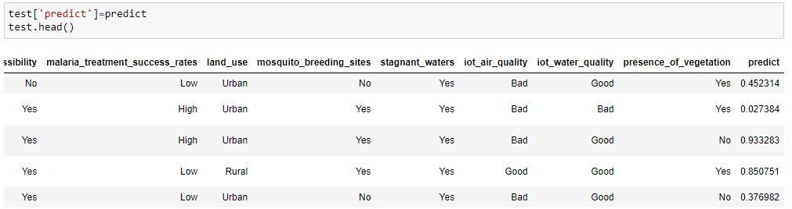

Figure 4: Predicted Output

Figure 4 is shows that the predict column in your dataset represents a numerical value that likely corresponds to a prediction generated by a machine learning model. In the context of malaria infection diagnosis or risk prediction, this value could signify various outcomes depending on the model's purpose. Here are a few possible interpretations Outbreak threshold value The predict value might represent the predicted probability of a malaria outbreak occurring in the area under the given conditions. For example, a value of 0.452314 might indicate a 45.23% likelihood of a malaria outbreak.

**CHAPTER 11**

**CONCLUSION AND FUTURE SCOPE**

**11.1 Conclusion**

The research on deep learning-based analysis for malaria infection diagnosis represents a significant advancement in the field of medical diagnostics, particularly for infectious diseases that have a profound impact on global public health. The traditional methods of malaria diagnosis, while effective, are fraught with limitations, including dependency on skilled personnel, susceptibility to human error, and the time-consuming nature of the process. These challenges are particularly pronounced in low-resource settings, where the shortage of skilled technicians and inadequate healthcare infrastructure often lead to delayed or inaccurate diagnoses, ultimately contributing to higher morbidity and mortality rates.

The integration of deep learning into malaria diagnosis offers a promising solution to these challenges. By training deep learning models on large datasets of labeled blood smear images, the proposed system can automate the detection and classification of malaria parasites. This automation significantly reduces the time required for diagnosis, minimizes human error, and provides consistent and accurate results regardless of the setting. The deep learning model can process and analyze medical images rapidly, making it possible to diagnose malaria with high accuracy even in remote or resource-limited areas where traditional microscopy may not be feasible.

Moreover, the scalability of deep learning-based systems makes them suitable for deployment in large-scale screening programs, potentially reaching a broader population and improving overall malaria control efforts. The use of AI in this context not only enhances the speed and accuracy of diagnosis but also democratizes access to high-quality diagnostic tools, making them available to regions that have traditionally been underserved.

**11.2 Future Scope**

The future scope of deep learning-based malaria diagnosis is vast and encompasses several areas for further research and development. One of the primary avenues for future work is the enhancement of the deep learning models used for diagnosis. While current models have demonstrated high accuracy, there is always room for improvement, particularly in increasing the model's ability to generalize across diverse populations and varying conditions of blood smears. This could involve the incorporation of more diverse and extensive datasets, as well as the development of more sophisticated algorithms that can handle the nuances of different malaria strains and the presence of other blood-related conditions.

Another significant area for future research is the integration of deep learning-based diagnostics with other technologies, such as mobile health (mHealth) platforms. By leveraging the widespread availability of smartphones and mobile devices, deep learning models could be embedded into mobile applications that allow healthcare workers in remote areas to perform on-the-spot diagnoses. This would enable real-time decision-making and ensure that patients receive timely treatment, which is crucial in managing and controlling the spread of malaria.

Additionally, the future could see the development of hybrid diagnostic tools that combine deep learning with traditional methods, such as microscopy. For instance, AI-powered software could be used to assist technicians by pre-screening blood smears and flagging areas of interest, thereby reducing the workload and improving the accuracy of manual diagnoses. This hybrid approach could provide a bridge between traditional and modern diagnostic methods, making advanced tools more acceptable and accessible in regions where the adoption of new technology may face resistance.

**REFERENCES**

[1] David H, Mannila H, Smyth PC. Principles of data mining. MIT Press, Cambridge; 2001.

[2] Koh HC, Tan G. Data mining application in healthcare. Journal of Healthcare Information Management. 2005;19(2).

[3] Tomar D, Agarwal S. A survey on data mining approaches for healthcare. International Journal of Bio-Science and Bio-Technology. 2013;5(5):241-266.

[4] World Health Organization. World Malaria Report: Geneva; 2012.

[5] Roca-Feltrer A, Carneiro I, Armstrong Schellenberg JR. Estimates of the burden of malaria morbidity in Africa in children under the age of 5 years. Trop Med Int Health. 2008;13:771–83.

[6] Ibrahim F, Abu N, Osman A, Usman J, Kadri NA. Comparison of different classification techniques using weka for breast cancer. Biomed 06, IFMBE Proceedings. Springer-Verlag Berlin Heidelberg Publisher. 2007;15:520-523.

[7] Boris M, Milan M. Prediction and decision making in health care using data mining. Kuwait Chapter of Arabian Journal of Business and Management Review. 2012;1(12).

[8] Sharma V, Ajai K, Lakshmi P, Ganesh K, Anuradha L. Malaria outbreak prediction model using machine learning. International Journal of Advanced Research in Computer Engineering & Technology (IJARCET). 2015;4(12).

[9] Kapor P, Rani R. Efficient decision tree algorithm using j48 and reduced error pruning. International Journal of Engineering Research and General Science. 2015;3(3): 2091-2730. [10] Leopard H, Cheruiyot KW, Kimani S. A survey and analysis of classification and regression data mining techniques for diseases outbreak prediction in datasets. The International Journal of Engineering and Science (IJES). 2016;5(9):01-11.

[11] Bbosa F, Ronald W, Peter J. Clinical malaria diagnosis: Ruled-based classification statistical prototype. Publisher: SpringerPlus. 2016;5:939.

[12] Witten HI, Frank E, Hall MA, Pal CJ. Data mining: Practical machine learning tools and techniques. Fourth Edition Morgan Kaufmann (Elsevier); 2017.

[13] Cao X, Maloney KB, Brusic V. Data mining of cancer vaccine trials: A bird's-eye view. Immunome Research. 2008;4:7. DOI: 10.1186/1745-7580-4-7 [14] Cios KJ, Moore GW. The uniqueness of medical data mining. To Appear in Artificial Intelligence in Medicine Journal; 2002.

[15] Witten IH, Eibe F, Christopher JP, Mark AH. The weka workbench “data mining: Practical machine learning tools and techniques”. Morgan Kaufmann, Fourth Edition. 2016;7. [16] Han J, Kamber M, Pei J. Data mining concepts and techniques third edition by Elsevier Inc. 2012;18- 19:622-624.

[17] Quinlan R. C4.5: Programs for machine learning. Morgan Kaufmann Publishers, San Mateo, CA; 1993.

[18] Sumner M, Eibe F, Mark H. Speeding up logistic model tree induction. In: 9th European Conference on Principles and Practice of Knowledge Discovery in Databases. 2005;675-683. [19] Hulten G, Laurie S, Pedro D. Mining time-changing data streams. In: ACM SIGKDD Intl. Conf. on Knowledge Discovery and Data Mining. 2001;97-106.

[20] Hall M, Eibe F, Geoffrey H, Bernhard P, Peter R, Witten H. The weka data mining software: An update. SIGKDD Explorations. 2009;11(1).